* The first table is named "users" and has the following columns (take a screenshot of the phpMyAdmin UI before clicking Save):
  + UserNo: integer, not null, primary key
  + UserId: varchar(15), not null
  + LName: varchar(25), not null
  + A screenshot of a computer

    AI-generated content may be incorrect.FName: varchar(25), not null
* The second table is named "products" and has the following columns (take a screenshot of the phpMyAdmin UI before clicking Save):
  + ProductNo: integer, not null, primary key
  + ProductId: varchar(10), not null
  + ProductName: varchar(50), not null
  + ProductDescription: varchar(150), null, default null

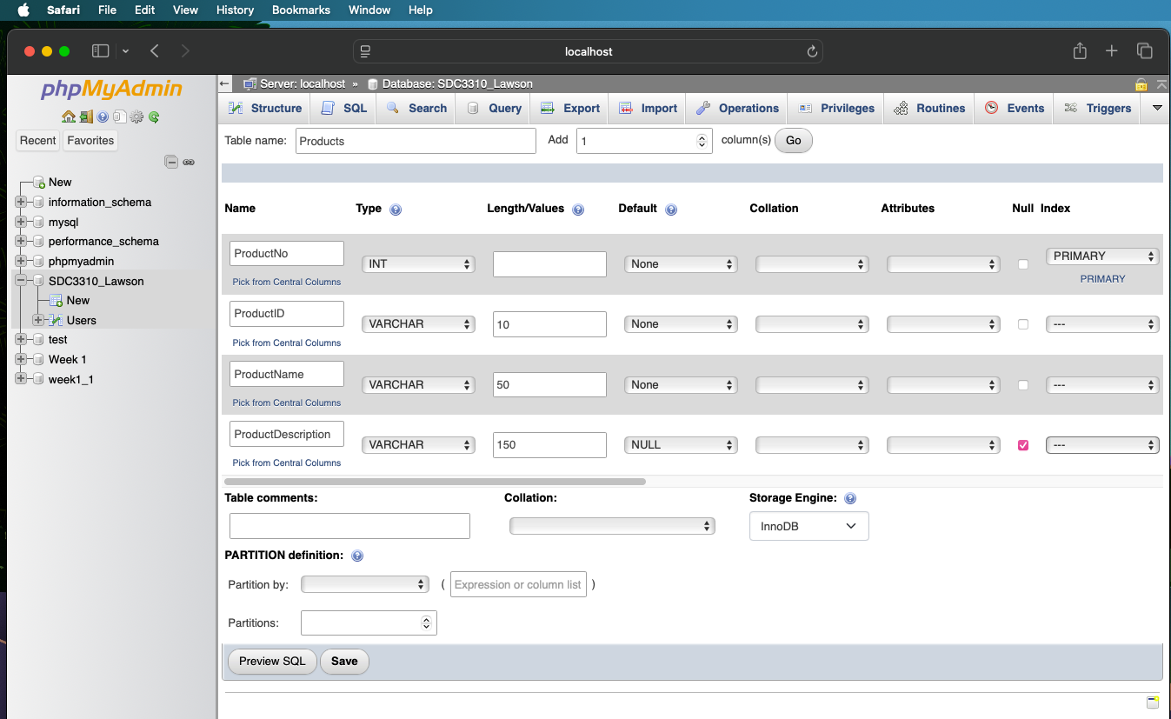

Following the creation of both tables, take a screenshot of the phpMyAdmin UI showing the tables and their columns.

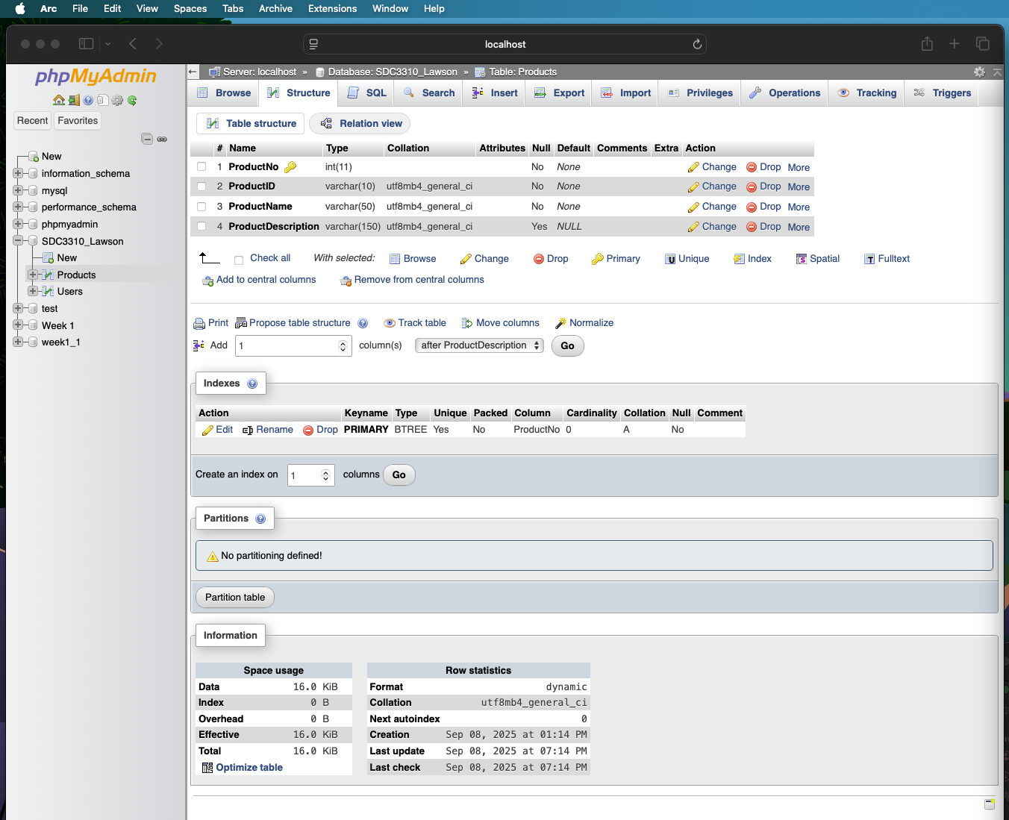

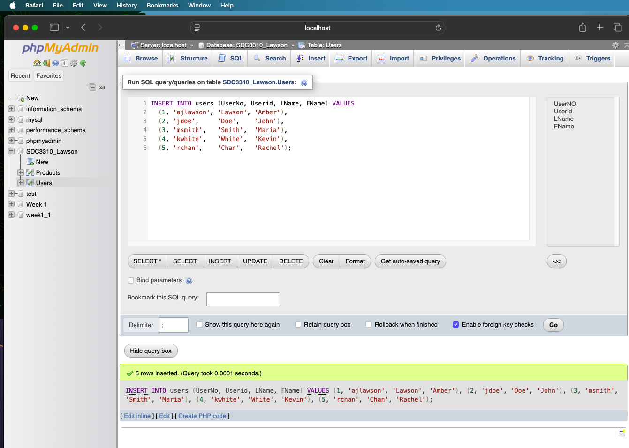GENERATE PRODUCTS AND USERS (ICON PACKS/THEMES FOR IPHONE☺)

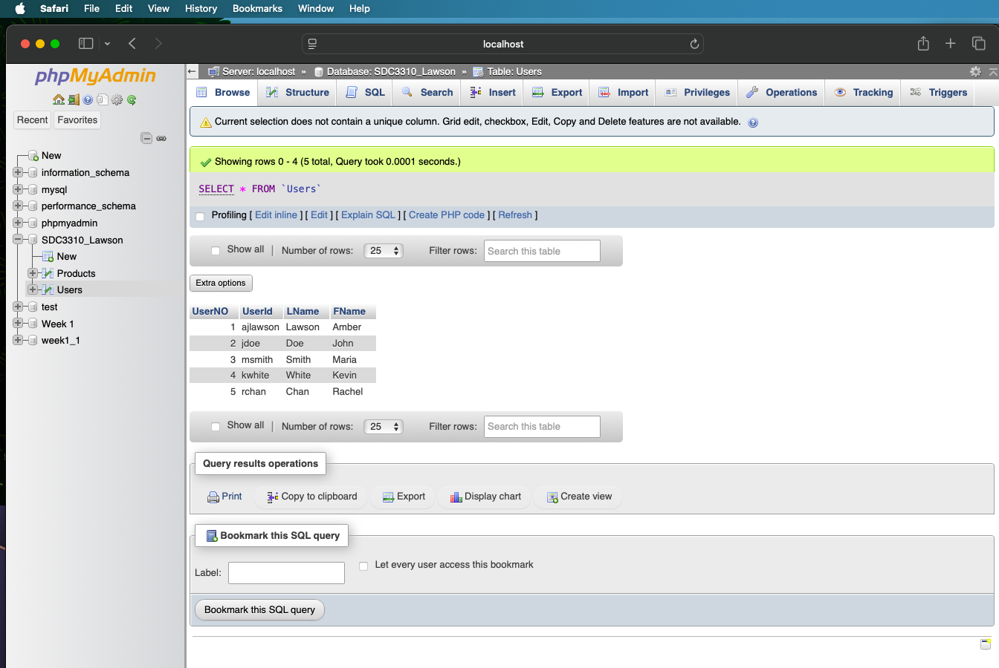

UPDATE/DELETE

